<Title>

<Title>

Version <1.0>

Class Name | Android Mobile Programming
Class Code | Android k15
Group | mMovie
Teacher | Khanh Nguyen
Project Manager | Khanh Nguyen
Assign Date
Complete Date
Author
Version | 1.0
Approved By
Approved Date

Table of Contents
1. Introduction 4
1.1 Purpose 4
1.2 Scope 4
1.3 Definitions, Acronyms and Abbreviations 4
1.4 References 4
2. OVERAL Description 4
2.1 Product Perspective 4
2.2 Product Features 4
2.3 User Documents 4
2.4 Assumptions 4
2.5 Constraints 5
3. Use case model 5
3.1 The Actors 5
3.2 The use cases 5
3.3 Use cases diagram 6
4. Functional Requirements 6
4.1 Feature Movie 6
4.1.1 Use case Search Movies _ UC_001 6
4.1.2 Use case List of Movies _ UC_002 7
4.1.3 Use case List upcoming movies_UC_003 7
4.1.4 Use case List movie news_UC_004 7
4.1.5 Use case Manage Favourite movie_UC_005 8
4.1.6 Use case Play trailer_UC_006 8
4.1.7 Use case View showtimes_UC_007 9
4.1.8 Use case Search movie news_UC_008 9
4.1.9 Use case Add favourite movie_UC_009 10
4.1.10 Use case Delete favourite movie_UC_010 10
4.1.11 Use case Edit favourite movie_UC_011 11
4.2 Feature Theatre 11
4.2.1 Use case Search Theatre_UC_012 11
4.2.2 Use case List theatres_UC_013 12
4.2.3 Use case Manage favourite theatre_UC014 12
4.2.4 Use case View detail_UC_015 13
4.2.5 Use case View theatre on map_UC_016 13
4.2.6 Use case Add favourite theatre_UC_017 14
4.2.7 Use case Delete favourite theatre_UC_018 14
4.2.8 Use case Edit favourite theatre_UC_019 15
5. Non-Functional Requirements 15
5.1 Usability 15
5.2 Reliability 15
5.3 Performance 15
5.4 Resource Consumption 16
5.4.1 Installability. 16
5.5 Interface Requirements 16
5.6 Security Requirements 16
5.7 Reports and Form templates Requirements 16
5.8 Other 16
6. Conclusion 16

Introduction

Purpose
This SRS Document contains the complete software requirements for the mMovie application and describes the design decisions, architectural design and the details design needed to implement the application. It provides the visibility in the design and provides information needed for the application support.

Scope
mMovie application is developing for Android Environment(AE) and use to replace the initial application. mMovie application is to build upon the AE in order to implement all of the process and friendly for users.

Definitions, Acronyms and Abbreviations
Term | Definitions, Acronyms and Abbreviations
mMovie | Mobile Movie
AE | Android Enviroment
UC | User Case
GUI | Graphic User Inteface

References
Android Application Fundamentals from: http://developer.android.com/guide/topics/fundamentals.html

OVERAL Description

Product Perspective
- It will be one of the best movie android application
- This is the software which beautiful GUI, support many function about a movie.

Product Features
- List movies, upcoming movies and showtimes
- List theatres, theatres detail, view theatres on map
- List movie trailers, play trailers, list movie news
- Manage movies and theatres favourites

User Documents
- How to view list movies, movie trailers...
- How to view theatres detail on map
- How to play movie trailer
- How to search movies, theatres
- How to manage movie and theatres favourites

Assumptions
- Only run on android 2.1 or higher
- Hardware configuration:
- CPU 1ghz
- RAM 128MB or higher

Constraints
- Using Android Phone such as HTC, Nexus, and Samsung…
- Running on Android 2.1 or higher.

Use case model

The Actors
- User: The user represents any person who will be using the mobile movie.

The use cases
System Features | Main Use Case | Use Case ID
Movie
 | Search Movies | UC_001
 | List of Movies | UC_002
 | List upcoming movies | UC_003
 | List movie news | UC_004
 | Manage Favourite movie | UC_005
 | Play trailer | UC_006
 | View showtimes | UC_007
 | Search movie news | UC_008
 | Add favourite movie | UC_009
 | Delete favourite movie | UC_010
 | Edit favourite movie | UC_011
Theatre
 | Search theatres | UC_012
 | List theatres | UC_013
 | Manage favourite theatre | UC_014
 | View detail | UC_015
 | View theatre on map | UC_016
 | Add favourite theatre | UC_017
 | Delete favourite theatre | UC_018
 | Edit favourite theatre | UC_019

Use cases diagram
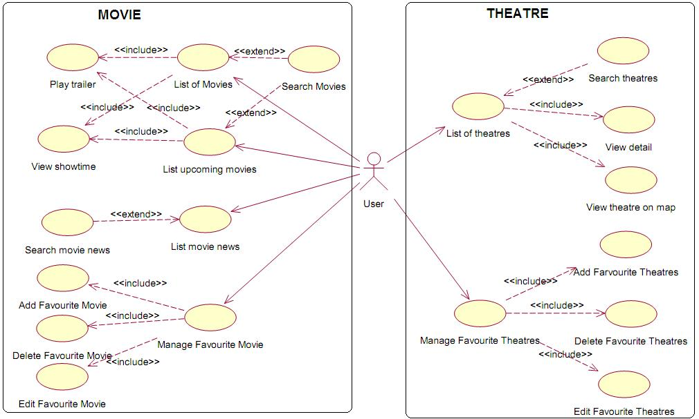

Functional Requirements

Feature Movie

Use case Search Movies _ UC_001
Use Case ID | UC_001
Name | Search Movies
Goal | Browse movie in database.
Actors | User.
Include | None.
Extended | - List movies.  - List upcoming movies.
Pre-conditions | - The movie application open.  - Click “Movie” symbol on menu.
Post-conditions | The movie, which the user wants to find, appears successfully.
Main Flow | - The user enters the name of movie in the search field and presses “Search" button.  - The movie will appear in the main view with the movie highlighted.
Exceptions | None.
Open Issues | If there is no movie in database, it appears nothing in the main view.

Use case List of Movies _ UC_002
Use Case ID | UC_002
Name | List of Movies
Goal | Appear all movie in the main view.
Actors | User.
Include | - Play trailer  - View showtime
Extended | None.
Pre-conditions | - The movie application open.  - Click “Movie” symbol on menu.
Post-conditions | The user view the all movies.
Main Flow | - The user accesses the mMovie application.  - The user click on “Movie “symbol on menu.  - All movies from database appear into the main view.  - The user reads movie name by scrolling through it.
Exceptions | None.
Open Issues | If there is no movie in database, it appears nothing in the main view.

Use case List upcoming movies_UC_003
Use Case ID | UC_003
Name | List upcoming Movies
Goal | Appear all upcoming movie in the main view.
Actors | User.
Include | - Play trailer  - View showtime
Extended | None.
Pre-conditions | - The movie application open.  - Click “Movie” symbol on menu.
Post-conditions | The user view the all new movies.
Main Flow | - The user accesses the mMovie application.  - The user click on “Movie “symbol on menu  - All upcoming movies from database appear into the main view.  - The user reads movie name by scrolling through it.
Exceptions | None.
Open Issues | If there is no movie in database, it appears nothing in the main view.

Use case List movie news_UC_004
Use Case ID | UC_004
Name | List movie news
Goal | Appear all movie news in the main view.
Actors | User.
Include | None.
Extended | Search movie news.
Pre-conditions | - The movie application open.  - Click “Movie” symbol on menu.
Post-conditions | The user view the all new movies.
Main Flow | - The user accesses the mMovie application.  - The user click on “Movie “symbol on menu  - All movies news from database appear into the main view.  - Th user click “news” symbol.  - The user reads movie news by scrolling through it.
Exceptions | None.
Open Issues | None.

Use case Manage Favourite movie_UC_005
Use Case ID | UC_005
Name | Manage Favourite movie
Goal | Manage favourite movie.
Actors | User.
Include | - Add favourite movie.  - Delete favourite movie.  - Edit favourite movie.
Extended | None.
Pre-conditions | - The movie application open.  - Click “Movie” symbol on menu.  - The movie is chose.
Post-conditions | The user could add, delete or edit favourite movie.
Main Flow | - The user accesses the mMovie application.  - The user click on “Movie “symbol on menu.  - All movies from database appear into the main view.  - The user click “Favourite” symbol.  - The user could manage favourite movie.
Exceptions | None.
Open Issues | None.

Use case Play trailer_UC_006
Use Case ID | UC_006
Name | Play trailer
Goal | Watch trailer of the movie.
Actors | User.
Include | None.
Extended | None.
Pre-conditions | - The movie application open.  - Click “Movie” symbol on menu.  - The movie is chose.
Post-conditions | The user watch trailer of the movie
Main Flow | - The user accesses the mMovie application.  - The user click on “Movie “symbol on menu.  - All movies from database appear into the main view.  - The user click “Play trailer” symbol.  - The user watch trailer of the movie.
Exceptions | None.
Open Issues | If there is no trailer in database, it appears nothing in the main view.

Use case View showtimes_UC_007
Use Case ID | UC_007
Name | View showtimes
Goal | View showtimes of the movie on next day.
Actors | User.
Include | None.
Extended | None.
Pre-conditions | - The movie application open.  - Click “Movie” symbol on menu.  - The movie is chose.
Post-conditions | The user view showtimes of the movie on next day.
Main Flow | - The user accesses the mMovie application.  - The user click on “Movie “symbol on menu.  - All movies from database appear into the main view.  - The user click “Showtimes” symbol.  - The user view showtimes of the movie
Exceptions | None.
Open Issues | If there is no showtimes in database, it appears nothing in the main view.

Use case Search movie news_UC_008
Use Case ID | UC_008
Name | Search movie news
Goal | Browser movie news in database.
Actors | User.
Include | None.
Extended | - List movie news.
Pre-conditions | - The movie application open.  - Click “Movie” symbol on menu.
Post-conditions | The movie news, which the user wants to read, appears successfully.
Main Flow | - The user enters the title of movie news in the search field and presses “Search" button.  - The movie news will appear in the main view with the movie news highlighted.
Exceptions | None.
Open Issues | If there is no news in database, it appears nothing in the main view.

Use case Add favourite movie_UC_009
Use Case ID | UC_009
Name | Add favourite movie
Goal | Add favourite movie in database
Actors | User.
Include | None.
Extended | None.
Pre-conditions | - The movie application open.  - Click “Movie” symbol on menu.  - The movie is chose.  - The user click “Favourite” symbol.
Post-conditions | The user add favourite movie in database.
Main Flow | - The user accesses the mMovie application.  - The user click on “Movie “symbol on menu.  - All movies from database appear into the main view.  - The user click “Favourite” symbol.  - The user add favourite movie.
Exceptions | None.
Open Issues | None.

Use case Delete favourite movie_UC_010
Use Case ID | UC_010
Name | Delete favourite movie
Goal | Delete favourite movie in database
Actors | User.
Include | None.
Extended | None.
Pre-conditions | - The movie application open.  - Click “Movie” symbol on menu.  - The movie is chose.  - The user click “Favourite” symbol.
Post-conditions | The user delete favourite movie in database.
Main Flow | - The user accesses the mMovie application.  - The user click on “Movie “symbol on menu.  - All movies from database appear into the main view.  - The user click “Favourite” symbol.  - The user delete favourite movie.
Exceptions | None.
Open Issues | None.

Use case Edit favourite movie_UC_011
Use Case ID | UC_011
Name | Edit favourite movie
Goal | Edit favourite movie in database
Actors | User.
Include | None.
Extended | None.
Pre-conditions | - The movie application open.  - Click “Movie” symbol on menu.  - The movie is chose.  - The user click “Favourite” symbol.
Post-conditions | The user edit favourite movie in database.
Main Flow | - The user accesses the mMovie application.  - The user click on “Movie “symbol on menu.  - All movies from database appear into the main view.  - The user click “Favourite” symbol.  - The user edit favourite movie.
Exceptions | None.
Open Issues | None.

Feature Theatre

Use case Search Theatre_UC_012
Use Case ID | UC_012
Name | Search theatre
Goal | Browse theatre in database.
Actors | User.
Include | None.
Extended | - List theatres
Pre-conditions | - The movie application open.  - Click “Theatre” symbol on menu.
Post-conditions | The theatre, which the user wants to find, appears successfully.
Main Flow | - The user enters the name of theatre in the search field and presses “Search" button.  - The theatre will appear in the main view with the theatre highlighted.
Exceptions | None.
Open Issues | If there is no theatre in database, it appears nothing in the main view.

Use case List theatres_UC_013
Use Case ID | UC_013
Name | List theatres
Goal | Appear all theatre in the main view.
Actors | User.
Include | - View detail.  - View theatre on map.
Extended | None.
Pre-conditions | - The movie application open.  - Click “Theatre” symbol on menu.
Post-conditions | The user view the all theatres.
Main Flow | - The user accesses the mMovie application.  - The user click on “Theatre “symbol on menu.  - All theatres from database appear into the main view.  - The user reads theatre name by scrolling through it.
Exceptions | None.
Open Issues | None.

Use case Manage favourite theatre_UC014
Use Case ID | UC_014
Name | Manage Favourite theatre
Goal | Manage favourite theatre.
Actors | User.
Include | - Add favourite theatre.  - Delete favourite theatre.  - Edit favourite theatre.
Extended | None.
Pre-conditions | - The movie application open.  - Click “Theatre” symbol on menu.  - The theatre is chose.
Post-conditions | The user could add, delete or edit favourite theatre.
Main Flow | - The user accesses the mMovie application.  - The user click on “Theatre “symbol on menu.  - All theatres from database appear into the main view.  - The user click “Favourite” symbol.  - The user could manage favourite theatre.
Exceptions | None.
Open Issues | None.

Use case View detail_UC_015
Use Case ID | UC_015
Name | View detail
Goal | View detail the theatre
Actors | User.
Include | None.
Extended | None.
Pre-conditions | - The movie application open.  - Click “Theatre” symbol on menu.  - The theatre is chose.
Post-conditions | The user view detail the theatre.
Main Flow | - The user accesses the mMovie application.  - The user click on “Theatre “symbol on menu.  - All theatres from database appear into the main view.  - The user choose the theatre.  - The user view detail the theatre by click “Detail” symbol.
Exceptions | None.
Open Issues | None.

Use case View theatre on map_UC_016
Use Case ID | UC_016
Name | View theatre on map
Goal | View address of the theatre on map.
Actors | User.
Include | None.
Extended | None.
Pre-conditions | - The movie application open.  - Click “Theatre” symbol on menu.  - The theatre is chose.
Post-conditions | The user view address of the theatre on map.
Main Flow | - The user accesses the mMovie application.  - The user click on “Theatre “symbol on menu.  - All theatres from database appear into the main view.  - The user choose the theatre.  - The user view detail the theatre by click “Map” symbol.
Exceptions | None.
Open Issues | If there is no address on map in database, it appears nothing in the main view.

Use case Add favourite theatre_UC_017
Use Case ID | UC_017
Name | Add Favourite theatre
Goal | Add favourite theatre in database.
Actors | User.
Include | None.
Extended | None.
Pre-conditions | - The movie application open.  - Click “Theatre” symbol on menu.  - The theatre is chose.  - The user click “Favourite” symbol.
Post-conditions | The user add favourite theatre in database.
Main Flow | - The user accesses the mMovie application.  - The user click on “Theatre “symbol on menu.  - All theatres from database appear into the main view.  - The user click “Favourite” symbol.  - The user add favourite theatre in database.
Exceptions | None.
Open Issues | None.

Use case Delete favourite theatre_UC_018
Use Case ID | UC_018
Name | Delete Favourite theatre
Goal | Delete favourite theatre in database.
Actors | User.
Include | None.
Extended | None.
Pre-conditions | - The movie application open.  - Click “Theatre” symbol on menu.  - The theatre is chose.  - The user click “Favourite” symbol.
Post-conditions | The user delete favourite theatre in database.
Main Flow | - The user accesses the mMovie application.  - The user click on “Theatre “symbol on menu.  - All theatres from database appear into the main view.  - The user click “Favourite” symbol.  - The user delete favourite theatre in database.
Exceptions | None.
Open Issues | None.

Use case Edit favourite theatre_UC_019
Use Case ID | UC_019
Name | Edit Favourite theatre
Goal | Edit favourite theatre in database.
Actors | User.
Include | None.
Extended | None.
Pre-conditions | - The movie application open.  - Click “Theatre” symbol on menu.  - The theatre is chose.  - The user click “Favourite” symbol.
Post-conditions | The user edit favourite theatre in database.
Main Flow | - The user accesses the mMovie application.  - The user click on “Theatre “symbol on menu.  - All theatres from database appear into the main view.  - The user click “Favourite” symbol.  - The user edit favourite theatre in database.
Exceptions | None.
Open Issues | None.

Non-Functional Requirements

Usability
- All of novice users can learn to operate major use cases without outside assistance.
- The main use cases must be accessible from the top screen.
- Easily take tickets by phone.

Reliability
- The system must have high accuracy.
- The system must never crash.

Performance
- Query response time must be fast and accuracy.
- All queries must return a response in < 2 seconds.

Resource Consumption
- The system must consume a maximum of 16 Mbytes of memory.
- The system will use no more than 25% of system resources.

Installability.
- A user can install and operate the program without assistance of any kind
- There must be an install program.
- The installation process will be kept at a minimum.

Interface Requirements
- A consistent GUI is required.
- The UI must be beautiful
- The UI must be user-friendly.
- The UI must be intuitive
- The UI will exhibit conceptual integrity.
- All menus must have a consistent format.
- All font and color must beharmonious combination.
- The user must be pleased with the GUI appearance.

Security Requirements
N/A

Reports and Form templates Requirements
N/A

Other
N/A

Conclusion
- mMoviewith handy features, meet the requirements of users. especially those interested inthe movie, we'll have all the highlights on film. ex: showtimes, theaters ...
- With Interface nice and friendly, in the future mMoviewill become an application be enjoyed and choice.
- We are going look forward to receiving your contributions for the product, so we can improve our products to satisfy the users' expectations.

---------- End of Document ----------

